AMERICAN MARITIME SAFETY, INC.
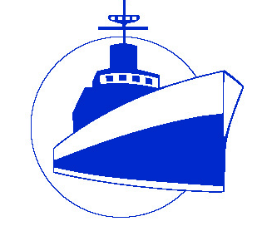

2022 ANNUAL MEMBERSHIP MEETING
PROXY FORM

Name of Company:
____________________________________________________________
Represented by the undersigned and being a member in good standing of
American Maritime Safety, Inc., (“AMS”) hereby constitutes and appoints:

George Diamantopoulos, Esq.

as my proxy to attend the meeting of the members of said association to be held on Thursday, October 13, at 11:00 a.m. via Zoom Video Communications Software, or any continuation or adjournment thereof, with full power to vote and act on my behalf as if I were present there at, giving to said proxy full power of substitution and revocation, and hereby revoking any other proxy given by me.

Name of Company Representative: ____________________________________
Authorized Signature: _____________________________ Date: ____________

PLEASE RETURN THIS PROXY FORM TO:
Bryan Kelk: bkelk@maritimesafety.org
or by Fax: (914) 997-6959

